CREATIVE EDUCATIONAL SERVICES
END OF TERM I EXAMINATIONS
2024

MATHEMATICS

NAME: ____________________________________________ BABY CLASS

1. Fill in the missing numbers.
1_____ 3_____ 5 _____ 7_____ 9 _____ 11 _____ 13_____ 15 _____ 17 _____ 19 _____

2. Count and write.
 =
 =
 =
 =
 =
3. Circle the correct number.


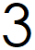

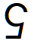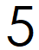
4. Read and copy number names
1 one 4 four
______________ ______________

2 two 5 five
______________ ______________

3 three 6 six
______________ ______________

5. Add the objects
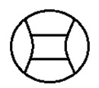+ =
 + =
 + =
+ =
 + =

6. Addition (+)
3 + 3 =
2 + 2 =
1 + 1 =
2 +1 =
5 + 5 =
Take away (-)
2 – 1 =
4 – 2 =
3 – 2 =
6 – 3 =
2 – 2 =

******Success ****

